Final Year Projects - Initial Planning document
Attached are three documents which you might like to consider when planning your own Final Year Project (FYP). The first two have been 'rescued' from Mike Hart's files and are provided by way of illustration.
1. Initial doodlings...
This document was actually written in the middle of the night when I had a quick brain-storm thinking about the major elements of a Ph.D
2. Plan of chapters with key bullet points
Within a day or so, the initial doodlings were tidied up into a series of chapter headings, with a few bullet points under each to indicate the major divisions of each chapter.
You should work on your own FYP plan as soon as you have undertaken the preliminary reading and present it a copy of it to your tutor at the start of your supervision.

This plan does not commit you in any way but it does provide both you and your tutor with a 'road map' indicating how you intend, at that stage, to go about your project. In practice, such plans are often revised as you make progress through the FYP.. Some chapters might get too large and have to be split into two whilst others, on reflection, can sensibly be combined into one.
3. Title page of completed dissertation
This is what the title page of the first draft of the dissertation looked like.

The lessons to be learnt from this are:

- 'Large oaks from little acorns grow' i.e. very large project starts off with your thoughts on one sheet of paper (which you may subsequently revise) '
- A fairly snappy title helps to concentrate your thought processes - can you describe the whole in one sentence ? For example, a friend or fellow course member asks '"What is your project about" and in one sentence you reply—Have a working title in mind and the final title can be applied at the completed draft stage.
- Having a plan is psychologically reassuring because you can 'project manage' the whole by deciding to do one chapter a fortnight (or other timescale).

- After your preliminary reading, it is better to get writing rather than wait until you have researched the whole...
initial.doc/27.11.2000

Evolution of a project – initial doodlings

Large image may load slowly!
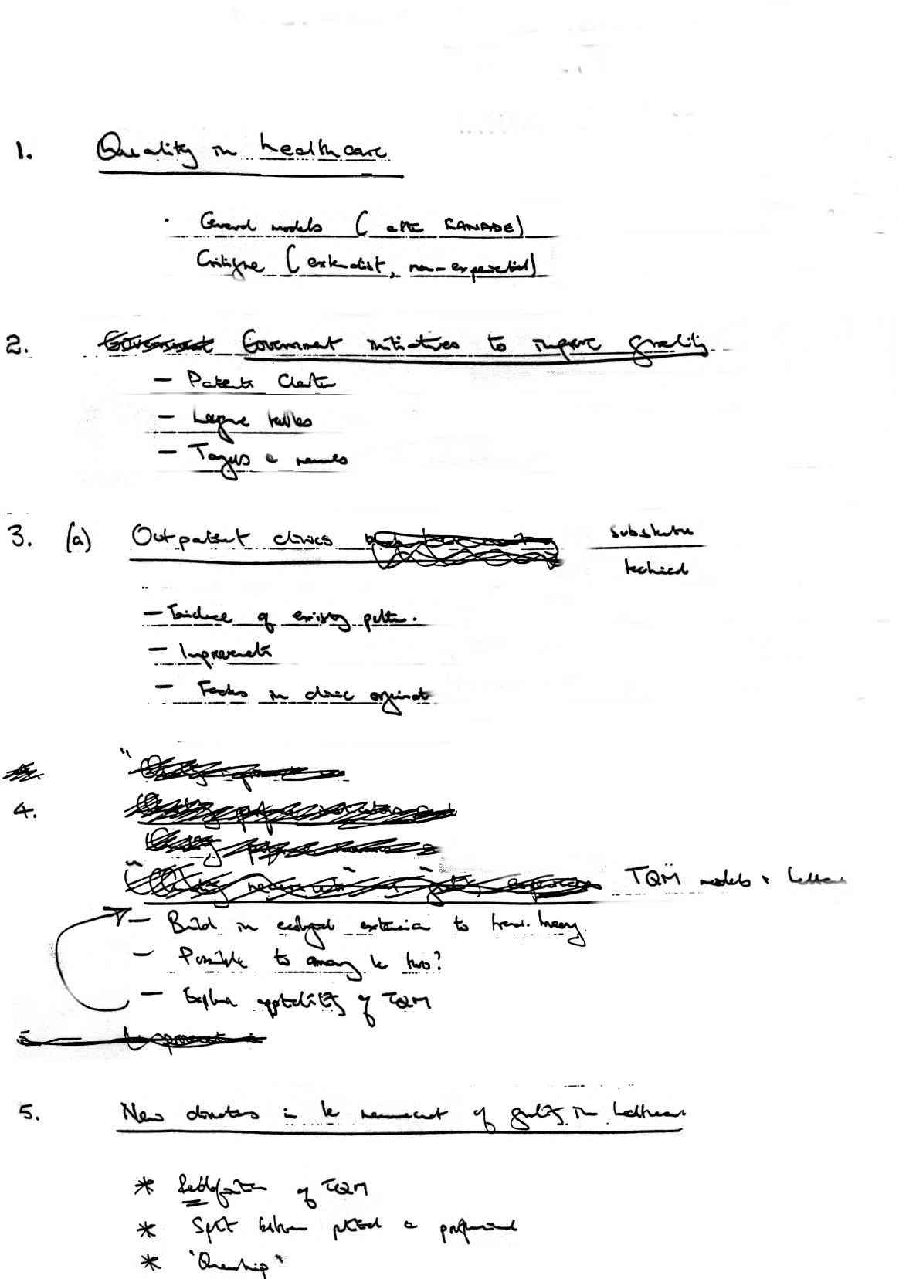

Evolution of a Project – initial plan of chapters

QUALITY IMPROVEMENT IN NHS OUTPATIENT CLINICS
CHAPTER 1 Quality in Healthcare

• General models of quality in healthcare
(Ranade,Ovretheit,Pollitt)
• Critique of the same (externalist, non-experiential)
• Government initiatives ('Working for Patients','Patients Charter',’League
Tables’)

CHAPTER 2 Outpatient clinics - measuring the quality
• The MOPAL program
• Measurement problems
• implementation of IT solutions

CHAPTER 3 Outpatient clinics - implementing improvements
• Substantive improvements in clinics
• Policies to improve clinics
• Importance of culture change

CHAPTER 4 Policy Implications of measuring quality improvements
• Measuring the measurable
• Goal displacement
• Determination of quality

CHAPTER 5 TQM Models in Healthcare
• Viability of directly importing TQM models
• The 'ecological critique'
• Is it possible to reconcile the two ?
• Evaluation of applicability of TQM models in healthcare

CHAPTER 6 New directions in the measurement of quality in healthcare
• Role of the 'consumer'
• servqual and its results
• Application of servqual to Outpatients

Evolution of a project - Contents page of completed project

TABLE OF CONTENTS

INTRODUCTION 1

CHAPTER 1 : Quality in Healthcare

Introduction 4
The Prevalence of the Quality Concept 4
Approaches to Quality 9
Quality in Healthcare 17
A survey of hospital discharge arrangements 25
(Paper 1) 26

CHAPTER 2 : Outpatient Clinics - measuring the quality

Background to the study 29
What was to be measured - and how ? 30
Some measurement and computational issues 32
The MOPAL system 33
Lessons learned from the monitoring exercise 34
The social context of data collection 34
The relevant variables ? 36
Data collected with a high degree of integrity ? 38
Data collected in a spirit of scientific disinterestedness ? 39
(Paper 2) 42
(Paper 3) 42

CHAPTER 3 : Outpatient clinics- implementing improvements

The outpatient clinic as an organisational arena 44
Improvements in Leicester General Hospital :
January 1992-March 1993 47
Comparison with other hospitals 50
Other substantive issues arising from the case study 52
Critical Incident analyses 53
(Paper 4) 57

CHAPTER 4 : Policy implications of measuring quality improvements

Measuring the measurable 59
Goal displacement 60
Waiting Times and the League Tables 61
League tables as a diversion 64
Performance Assessment and Performance Measurement 67
Producer and Consumer defined measures of performance 71
(Papers 5,6) 75

CHAPTER 5 : TQM Models in Healthcare

TQM in the public sector 78
TQM in Healthcare 80
Evaluation of TQM in the NHS 82
The decline and fall of TQM in the NHS ? 84
An 'ecological' approach to quality 86
(Papers 7-9) 90

CHAPTER 6 : New directions in the measurement of quality in
healthcare

The role of the consumer 92
Patient satisfaction surveys 93
Perceptions, Expectations and Patient Satisfaction 95
Interpretive approaches to satisfaction 98
The role of consumer audit 100
(Papers 10-12) 104

CHAPTER 7 : A qualitative investigation into outpatient clinic quality

The need for qualitative approaches to quality 107
Models of quality - are most measures of quality static ? 107
Fourth Generation evaluative methodologies 109
Qualitative study of Paediatric outreach clinics in Leicestershire 111
Sample Design and sampling details 111
Clinic Sampling Frame 112
Clinics selected for the Investigation 113
Data collection 113
Results 114
‘Time’ and ‘Trajectory’ in the organisation of a clinic 122
Episode distillation in Clinic Life 130
Elements of a qualitative model of outpatient experiences 132
Operationalisation of the qualitative model 137

CHAPTER 8 : Concluding observations

Quality Assurance or Monitoring a Quality Standard 139
An ecological approach to quality management 140
Further avenues for research 142

REFERENCES

Go Back

